CITY OF LOS ANGELES
California
SYLMAR NEIGHBORHOOD COUNCIL  PRESIDENT: Kurt Cabrera-Miller  VICE PRESIDENTS:  Administration: Andres Rubalcava  Communication: Jose Velasquez  TREASURER: George Ortega  SECRETARY: Kathy Bloom |  | 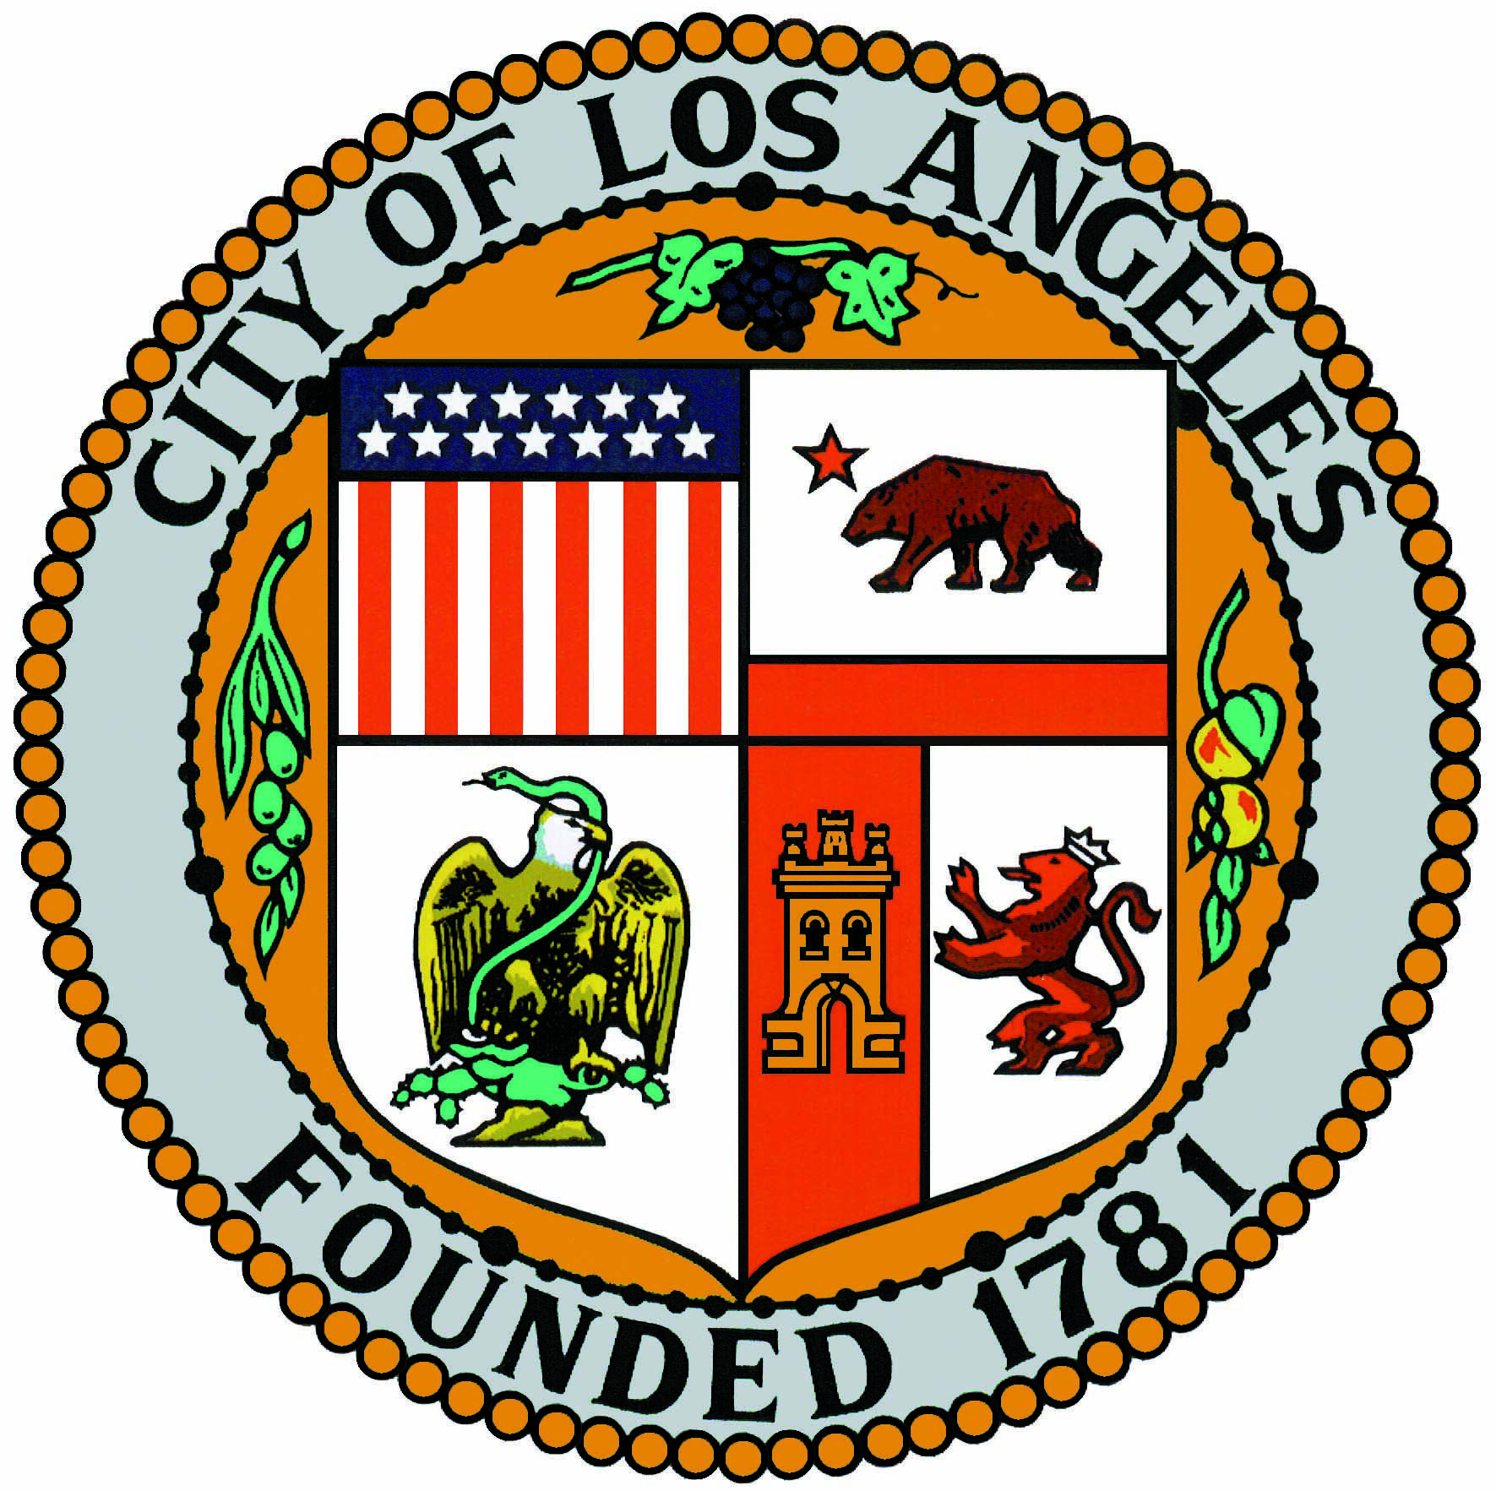 | Office: 13521 Hubbard Street  Sylmar Ca. 91342  Telephone: (818) 833-8737  E-mail: Board@SylmarNC.org  Website: www.SylmarNC.org

SYLMAR NEIGHBORHOOD COUNCIL

OUTREACH COMMITTEE
MEETING AGENDA

Tuesday, September 5th, 2023, 6:30 pm

This meeting is held
in person and via Zoom
Sylmar Neighborhood Council Office
13521 Hubbard Street Sylmar, CA 91342
Please use the link https://us02web.zoom.us/j/87073378790 to join webinar; and/or,
Dial (669) 900-6833 enter ID 870 7337 8790 and Press # to join the Meeting via Phone

Kurt Cabrera-Miller, Chairperson
Committee Members - Ann, Job, George Ortega, Maria Strmsek, Jose Velasquez.

The Agenda is posted for public review at the Sylmar Neighborhood Council Office, 13521 Hubbard Street, Sylmar, CA 91342 Agendas may also be found on the SNC website at www.SylmarNC.org. You may also subscribe to receive them via email through the City’s Early Notification System (ENS) at the following link: http://www.lacity.org/government/Subscriptions/NeighborhoodCouncils/index.htm

Si requiere servicios de traducción, favor de avisar al Concejo Vecinal 3 días de trabajo (72 horas) antes del evento. Por favor contacte por correo electrónico board@sylmarnc.org o por telephono 818-833-8737 para avisar al Concejo Vecinal.

Public comment cannot be required to be submitted in advance of the meeting, only real-time public comment is required. If there are any broadcasting interruptions that prevent the public from observing or hearing the meeting, the meeting must be recessed or adjourned. If members of the public are unable to provide public comment or be heard due to issues within the Neighborhood Council’s control, the meeting must be recessed or adjourned.
`
Every person wishing to address the Board must dial (669) 900-6833 and enter 870 7337 8790 and then press # to join the meeting. Instructions on how to sign up for public comment will be given to listeners at the start of the meeting.

PUBLIC INPUT AT NEIGHBORHOOD COUNCIL MEETINGS Comments from the public on agenda items will be heard only when the respective item is being considered. Comments from the public on other matters not appearing on the agenda that are within the Board’s jurisdiction will be heard during the General Public Comment period. Please note that under the Brown Act, the Board is prevented from acting on a matter that you bring to its attention during the General Public Comment period; however, the issue raised by a member of the public may become the subject of a future Board meeting. Public comment is limited to 2 minutes per speaker, unless adjusted by the presiding officer of the Board.

The Neighborhood Council system enables meaningful civic participation for all Angelenos and serves as a voice for improving government responsiveness to local communities and their needs. We are an advisory body to the City of Los Angeles, comprised of stakeholder volunteers who are devoted to the mission of improving our communities.

- Call to Order

- Roll Call

- Housekeeping: Sign-in Sheets, Speaker Cards for public comments, Recording and Timekeeper, facilities information.

- Public Comment on matters not appearing on the agenda.

- Update with a Discussion and possible action in the development, planning and mapping of “Bark-Tober” the SNC Animal Resource Fair, taking place on October 14th 2023 at El Cariso Park. (13100 Hubbard St. Sylmar, CA 91342)

- Discussion and Possible Action in the planning and scheduling of the SNC/Sylmar Community Holiday party to take place in December ((12/14/23 date pending)).

- Discussion and Possible Action in the SNC involvement in community events and activities for the months of September, October and November.

- Discussion and Possible Action in purchasing SNC branded items for outreach.

- Discussion and Possible Action: Methods, Technologies, Tools and guidelines with multimedia meeting presentations. (PowerPoint, Zoom, Website, etc.)

- Closing Remarks, Announcements, Acknowledgements and Adjournment.

All Agenda items may include presentations, discussions and actions by the Committee for recommendations to the SNC Board of Directors. The Board of Directors may discuss the recommendations and take action on the item, which could result in a Community Impact Statement to the City and/or a position letter to a City agency.

The Stakeholders may comment on any Agenda item only when the item comes up for discussion. The Committee will determine the length of discussion and comment times. The attending stakeholders may be polled for their opinion on any Agenda item before the Committee takes action for a recommendation to the Board. Comments from the stakeholders on other matters not appearing on the agenda that are within the Board’s jurisdiction will be heard during the General Public Comment period. Please note that under the Brown Act, the Board is prevented from acting on a matter that you bring to its attention during the General Public Comment period; however, the issue raised by a stakeholder may become the subject of a future Board meeting.

Any Committee action may be reconsidered following the Meeting when the original action occurred. A Committee Member makes a Motion for Reconsideration and if approved another vote on the issue takes place based on the reasoning for the reconsideration. The Committee Member must have been on the prevailing side of the action/issue.
As a covered entity under Title II of the Americans with Disabilities Act, the City of Los Angeles does not discriminate on the basis of disability and upon request will provide reasonable accommodation to ensure equal access to its programs, services, and activities. Sign language interpreters, assistive listening devices, or other auxiliary aids and/or services may be provided upon request. To ensure availability of services, please make your request at least 3 business days (72 hours) prior to the meeting by contacting the Department of Neighborhood Empowerment by calling (213) 978-1551 or email: NCsupport@lacity.org

Public Posting of Agendas -
Neighborhood Council agendas are posted for public review as follows:
● Sylmar Neighborhood Council Office - 13521 Hubbard St. Sylmar, CA 91342
● http://www.SylmarNC.org
● You can also receive our agendas via email by subscribing to L.A. City’s Early Notification System (ENS)
Notice to Paid Representatives -
If you are compensated to monitor, attend, or speak at this meeting, City law may require you to register as a lobbyist and report your activity. See Los Angeles Municipal Code Section 48.01 et seq. More information is available at ethics.lacity.org/lobbying. For assistance, please contact the Ethics Commission at (213) 978-1960 or ethics.commission@lacity.org

Public Access of Records - In compliance with Government Code section 54957.5 non-exempt writings that are distributed to a majority or all of the committee in advance of a meeting, may be viewed by visiting our website at http://www.SylmarNC.org or at the scheduled meeting. In addition, if you would like a copy of any record related to an item on the agenda, please contact committee Chair Kurt Cabrera-Miller at 818-833-8737 or email: kurt.cabrera-miller@gmail.com.

Reconsideration and Grievance Process -
For information on the NC’s process for board action reconsideration, stakeholder grievance policy, or any other procedural matters related to this Council, please consult the NC Bylaws. The Bylaws are available at our Board meetings and our website http://www.SylmarNC.org.
Committee Meeting Minutes are available on the SNC website www.SylmarNC.org

