CITY OF LOS ANGELES
CALIFORNIA
SYLMAR NEIGHBORHOOD COUNCIL  PRESIDENT: Kurt Cabrera-Miller  VICE PRESIDENTS:  Administration: (Open Position)  Communications: Maria Silva  TREASURER: (Open Position)  PUBLIC RELATIONS: David M. Rodriguez | 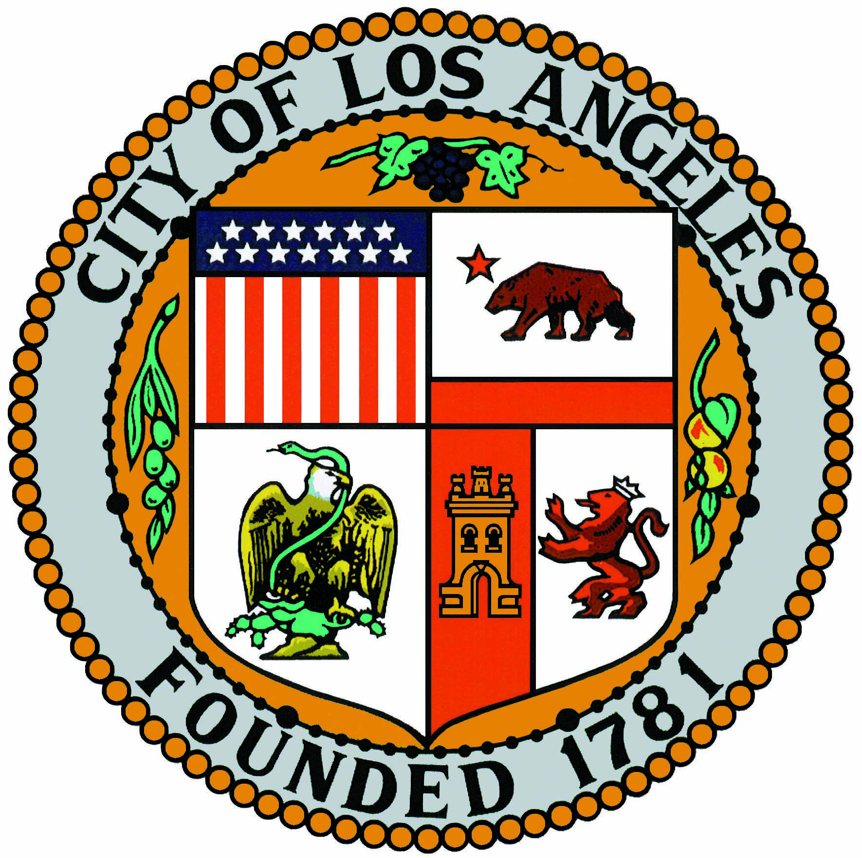 | P.O. 921023, Sylmar, CA 91392-1023  Telephone: (818) 833-8737  E-mail: Board@SylmarNC.org  Website: www.SylmarNC.org
SYLMAR NEIGHBORHOOD COUNCIL
SPECIAL EQUESTRIAN COMMITTEE – MINUTES
EL Potrerito Western Wear
13197-C Gladstone Sylmar Ca 91342.
Wednesday, July 19, 2017 6:30 pm to 8:00 pm

- Call to Order 6:45 pm

- Roll Call

- Housekeeping: Sign-in Sheets, Speaker Cards for public comments, Recording and Timekeeper.

- General Public Comment on matters not appearing on the agenda.

- Discuss and Possible Action for the “Make Your Horse Count Day” for 2018 outline of planning. Review budget, event planning etc. Date to be May 20, 2018 same time same place, Lots of discussion on how we could be more organized and better follow thru with the vendors, we need to get certifications in earlier and have then ready the day of the event. Music was OK with year. But we need to work and schedule the different types of music thru out the day. We all loved the children events and would like to expand them a little more.

- Discuss and possible action for schedule of events for the year: rides, community events and discussion about the committee “wish list”.- Table

- Discussion & Update of Community improvements: Signal lights, signage, trail fence etc. We really need to connect with the new council office to see the interest in our equestrian community.

- Committee Member Comments on subject matters within the Committee’s jurisdiction and further direction.

- Future Agenda Items: Date of next meeting to be discussed. Please e-mail Cheri.Blose@SylmarNC.org by TBA

- Adjourned 8:05 pm

