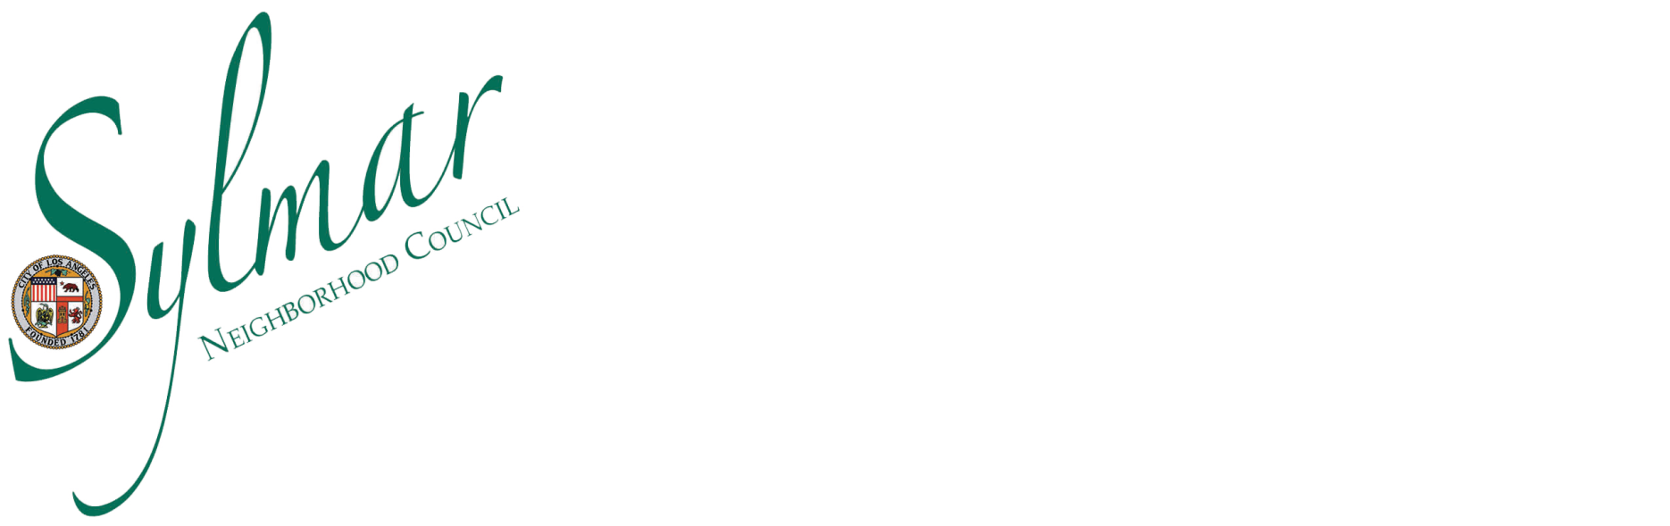

Officers
President: Tammy Flores
Vice President of Administration: Diane Valencia
Vice President of Communications: Maria Silva
Treasurer: Alex Guerrero
Public Relations Coordinator: David M. Rodriguez

Joint Special Meeting of the EMERGENCY PREPAREDNESS COMMITTEE and BOARD - AGENDA

Tuesday, August 16, 2016 5:30 pm to 7:30 pm
Sylmar Public Library, Community Room, 14561 Polk St. Sylmar, CA 91342
John Pacheco, Chairperson

Out of an abundance of caution due to the possible attendance and participation of a majority of Sylmar Neighborhood Council Board Members at this Committee meeting, this meeting is noticed as a Joint Meeting of the Committee and the Board, in adherence with the State’s Brown Act. No action will be taken on behalf of the Board at this meeting of the Committee. Only Committee Members are allowed to vote.

The Agenda is posted for public review at the Los Angeles Public Library (Sylmar Branch), 14561 Polk Street, Sylmar, CA 91342. As a courtesy, and as time permits, agendas may be emailed to Stakeholders if requested. Agendas may also be found on the SNC website at www.SylmarNC.org. You may also subscribe to receive them via email through the City’s Early Notification System (ENS) at the following link: http://www.lacity.org/government/Subscriptions/NeighborhoodCouncils/index.htm

Si requiere servicios de traduccion, favor de notificar a la oficina 3 días de trabajo (72 horas) antes del evento. Si necesita asistencia con esta notificacion, por favor llame a nuestra oficina al (818) 833-8737.

Stakeholders may comment on any Agenda item only when the item comes up for discussion. The Committee will determine the length of discussion and comment times. The attending stakeholders may be polled for their opinion on any Agenda item before the Committee takes action for a recommendation to the Board. Comments from the stakeholders on other matters not appearing on the agenda that are within the Committee’s jurisdiction will be heard during Public Comment on matters not appearing on the agenda. Please note that under the Brown Act, the Board is prevented from acting on a matter that you bring to its attention during the General Public Comment period; however, the issue raised by a stakeholder may become the subject of a future Board meeting.

Agenda items may be addressed in a different order and/or at different times.

- Call to Order.

- Housekeeping, Sign-In Sheets.

- Public Comment on non-agendized matters, within the Committee’s subject matter jurisdiction.
- Welcome and Introductions.

- Update on Proposed Budget for 2016 Emergency Preparedness Committee.

- Discussion and Possible Action on Proposal to Conduct Emergency Preparedness/CPR and First Aid Training for SNC Board.

- Discussion and possible Action on creation of a Sylmar CERT program.

- Recess.

- Report from Public Safety Liaison.

- Guest Speaker. Jon Brown, Disaster Program Manager, Territory 1, American Red Cross

- Discussion on lessons learned from recent Sand Fire operations.

- Update on our participation in the October Sylmar Resource Fair and Town hall.
- Discussion on Proposal to Conduct Special Equestrian Rescue Class for LA City Fire Department.
- Update on Schedule/Topics for Guest Speakers.
- Discussion and Possible Action to recruit an EPC P.R./Marketing Volunteer.
- Committee Member Comments on subject matters within the committee’s jurisdiction.
- Future Agenda Items: Please e-mail the EPC Chair at John.Pacheco@sylmarnc.org by the first of the month for that months’ meeting.

- Next Meeting; Tuesday, September 20, 2016 Sylmar Public Library-Community Room.

- Closing Remarks, Announcements, Acknowledgements and Adjournment.

All Agenda items may include presentations, discussions and actions by the Committee for recommendations to the SNC Board of Directors. The Board of Directors
may discuss the recommendations and take action on the item, which could result in a Community Impact Statement to the City and/or a position letter to a City agency.

Any Committee action may be reconsidered following the Meeting when the original action occurred. A Committee Member makes a Motion for Reconsideration and if approved another vote on the issue takes place based on the reasoning for the reconsideration. The Committee Member must have been on the prevailing side of the action/issue.

As a covered entity under Title II of the Americans with Disabilities Act, the City of Los Angeles does not discriminate on the basis of disability and upon request, will provide reasonable accommodation to ensure equal access to its programs, services, and activities. Sign language interpreters, assistive listening devices, or other auxiliary aids and/or services may be provided upon request. To ensure availability of services, please make your request at least three business days (72 hours) prior to the meeting you wish to attend by contacting the Sylmar Neighborhood Council Vice President of Administration, Diane Valencia by phone at (818) 833-8737 or email to Diane.Valencia@sylmarnc.org

Reconsideration of Agenda Items - Bylaws (Article VIII)
The Board may reconsider or amend its actions through the following Motion for Reconsideration process:
- Before the Board reconsiders any matter, the Board must approve a Motion for Reconsideration. The Motion for Reconsideration must be approved by official action of the Board. After determining that an action should be reconsidered, the Board has the authority to re-hear, continue, or take action on the item that is the subject of reconsideration within any limitations that are stated in the Motion for Reconsideration.
- The Motion for Reconsideration must be brought, and the Board's approval of a Motion for Reconsideration must occur, either during the same meeting where the Board initially acted or during the Board's next regularly scheduled meeting or at a special meeting within these specified time frames to address a Motion for Reconsideration.
- A Motion for Reconsideration may be proposed only by a Member of the Board who previously voted on the prevailing side of the original action that was taken by the Board (the "Moving Board Member").
- The Moving Board Member may make the Motion for Reconsideration orally during the same meeting where the action that is the subject of reconsideration occurred, or by properly placing the Motion for Reconsideration on the agenda of a meeting that occurs within the allowed specified periods of time as stated above.
- In order to properly place the Motion for Reconsideration on the agenda of the subsequent meeting, the Moving Board Member shall submit a memorandum to the Executive Committee in advance of the deadline for posting notices for the meeting.
- A Motion for Reconsideration that is properly brought before the Board may be seconded by any Member of the Board.
- This reconsideration process shall be conducted at all times in accordance with the Brown Act.

In compliance with Government Code section 54957.5, non-exempt writings that are distributed to a majority or all members of the Committee in advance of a meeting, may be viewed at the Neighborhood Council meeting or on the Neighborhood Council website by clicking or visiting www.sylmarnc.org. Any questions and/or comments regarding this agenda may be submitted to Board members via the emails listed on the website (www.sylmarnc.org).

Committee Meeting Minutes are available on the SNC website www.SylmarNC.org

