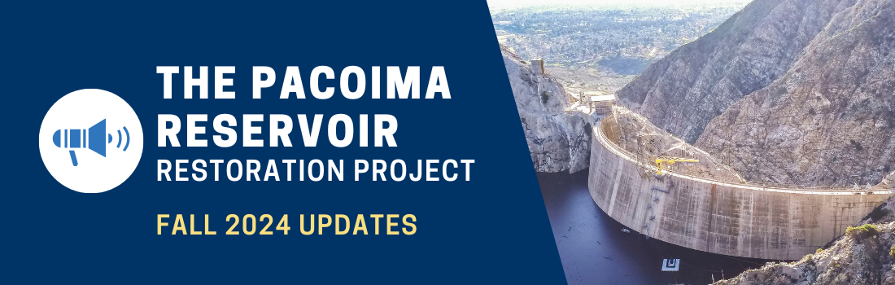

Need a refresher on why this Project is so important? Look no further than this edition of the Pacoima Reservoir Restoration Project Newsletter.
________
Pacoima Dam, Water Conservation, and You
Did you know Pacoima Dam can store an incredible 1.98 billion gallons of water? That’s more than 4,000 Olympic swimming pools put together. This water storage capacity helps Pacoima and surrounding water-scarce communities combat drought by capturing stormwater to recharge the region’s groundwater basins.
Over time, much of this storage capacity gets filled by sediment and debris that washes in during storms. Storms that follow fires can significantly increase erosion, leading to reservoirs filling with large amounts of sediment and debris. Pacoima Dam has a 28.2 square-mile watershed and 96% of its area has been burned at least once since 2008.
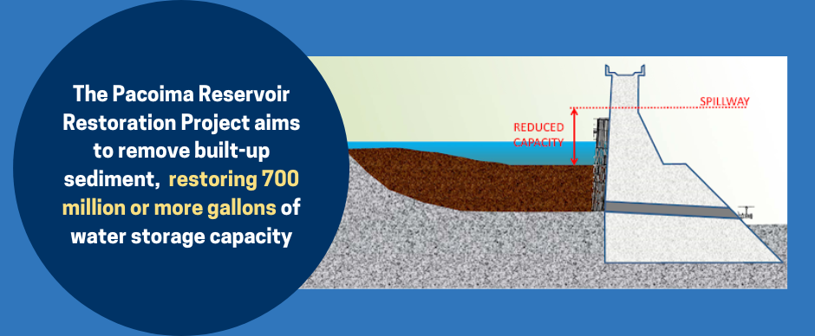
That’s why the Pacoima Reservoir Restoration Project aims to remove this sediment and debris, restoring an incredible 300 million gallons of water storage capacity to Pacoima Dam in the Project’s first phase alone. An additional 400 - 800 million gallons of capacity will be restored in future phases of the Project.
To learn more about the Project and how this sediment will be removed, please visit PacoimaProject.com
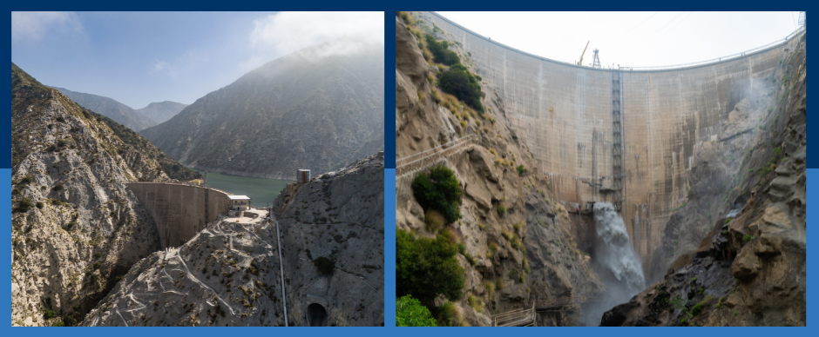
Protecting our Communities from Floods
With the past two years of above average rainfall, Los Angeles residents experienced potential flood risks to their communities. In order to reduce flood risk for the communities downstream, Pacoima Dam has the ability to strategically release water in controlled amounts up to its spillway elevation.
But due to sediment buildup, Pacoima Dam’s ability to do this has been considerably limited. Additional post-fire storms could threaten to block the dam’s remaining inlets, rendering the dam inoperable. The Pacoima Reservoir Restoration Project aims to ensure the dam’s ability to operate and provide critical flood protection for years to come.
The Draft Environmental Impact Report (EIR)
The Pacoima Reservoir Restoration Progress is maintaining steady progress through its early planning phases. The Draft Environmental Impact Report is currently being drafted. As planned, look forward to this crucial document being made available for public review in 2025.
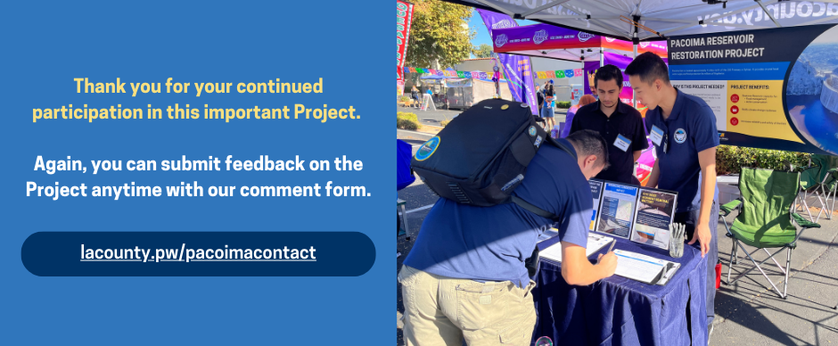
Other Projects In Your Area
LA County Public Works manages an integrated system of infrastructure projects throughout the County, ensuring safe, clean, and reliable water resources for all residents.
Click of the below links to learn more about other ongoing projects near you:
- The Devil's Gate Reservoir Annual Maintenance Project
- Pacoima Spreading Grounds Improvement Project
- The Big Tujunga Wash Mitigation Area
- Rory Shaw Wetlands Project
Sincerely,
The Pacoima Reservoir Restoration Project Team

